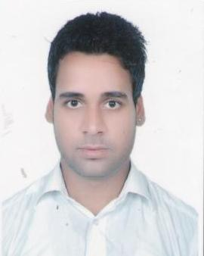
CURRICULUM VITAE

Manjeet Jajoria

Address: - RZ-92, Nala Par Basti East Sagarpur New Delhi. \\\\
Mobile No: - 9899709448
Email ID: - kapoorrahul626@gmail.com

- CAREER OBJECTIVE

I want to do work with India’s most valuable corporation, where I can utilize my abilities and enhance my domain knowledge and I can contribute my full potential to generate the revenue for the organization.

- ACADEMIC QUALIFICATION
Degree / Certificate | Institute / University | Year of passing
B.Com | Delhi University | 2012
Intermediate | CBSE Board | 2009
High school | CBSE Board | 2007

- EXPERIENCE

- Worked at Uae Exchange & Financial Services Ltd. in March 2013 to till July 2015

WORK PROFILE:-
- Joined to Uae exchange as A cashier.
- Foreign currency sale. (under to RBI)
- Foreign currency purchased.
- Foreign currency card like, yes bank card, axis bank card or go cash card.
- Receive money from abroad by MONEY GRAM OR EXPRESS MONEY.
- Send money to abroad by REMETTANCE OR SWIFT.
- Send money to any where in India in any bank by IMPS & NEFT.

- Worked In Concentrix Daksh Service Pvt. Ltd (AMAZON) From August 2015to To May 2016 -(GURGAON)
JOB RESPONSBILITIES.

- Handling customer queries through live web chat.
- Attracts potential customers by answering product and service questions; suggesting information about other products and services.
- Opens customer accounts by recording account information.
- Maintains customer records by updating account information.
- Resolves product or service problems by clarifying the customer's complaint; determining the cause of the problem; selecting and explaining the best solution to solve the problem; expediting correction or adjustment; following up to ensure resolution.

- STRENGTHS

- My family is my first priority.
- My strength is flexible and easy going person.
- I can work in a team or individual.
- I can prove my self in any situation

- WEEKNESS

- Easily trusting people but not taking their opinions.
- I'm restless towards my work until it complete and I focus only one thing at a time.
- my imagination too much high, and try to control on it.

- PERSONAL DETAILS
Date of Birth | 24th March 1991
Father’s Name | MR. Ashok Kumar
Gender | Male
Marital status | Single
Languages Known | Hindi & English
Nationality | Indian

Date-....………….. Signature: -Manjeet Jajoria
Place- Delhi

